Operating Instructions

# Installation [Version 8.0]

1. Install Student Register Software provided on the CD.
2. Install Urdu Language provided as an installed component – ‘language’ directory on the target machine.
3. Install Font (Alvi Nastaleeq) provided as an installed component – ‘urdu fonts’ directory on the target machine.
4. Now go to Control Panel, in the ‘Region and Language’ select country as Pakistan, language as Urdu(Islamic Republic of Pakistan) and input language(Keyboard, i.e., Phonetic Keyboard).

# Operation

1. After installation, I hope you confirmed \database directory inside product directory.
2. The installer has created an icon showing میرا سکول on your desktop which you can double-click to run the software.

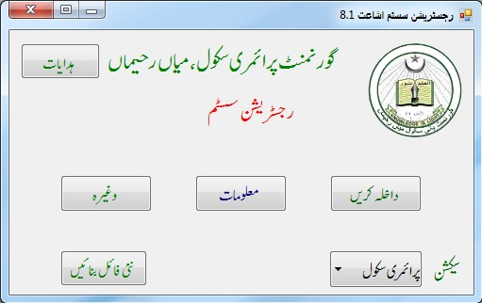

Fig. 1

1. Fig. 1 is the main screen of the software.
2. On the bottom-right corner a drop-down Combo box is given showing سیکشن as its title. It is used to select the section of the school. This will set one of the following databases as your current database.
   1. پرائمری سکول
   2. مڈل سکول
   3. ہائی سکول

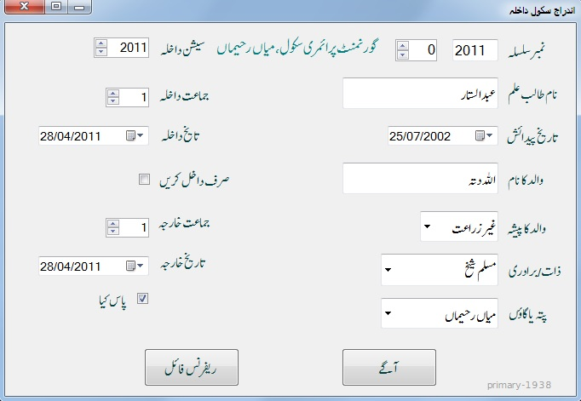

Fig. 2

1. On the left-top corner a help button is provided showing basic help as well as some historical pictures of pioneers of Govt. High School, Mian Rahiman.
2. داخلہ کریں is the data entry screen opening button. It will show a screen as Fig. 2
3. Here you can enter data for newly registering students.
4. It has a few features. Top-right box is used to enter Registration No of the new student. It should be unique and start after the already entered number.
5. Enter name of the new student. It provides auto complete names for student name and father name text boxes. To reject or accept auto complete suggestion, press Escape or enter respectively.
6. You can take reference from the other databases to use already entered data. To do this click ریفرنس فائل button and select a file. This will enable you to get already entered data quickly filled into you right-column of input boxes. Right-click on the entered name a list will be appeared on the screen with similar names. If the name you

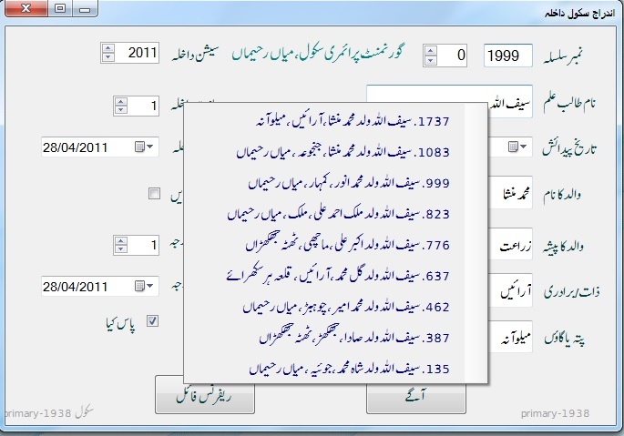

Fig. 3

need is there in the list click on it. Otherwise click outside the list and go on entering data for the new student.

1. The up-down box shown on the upper-right corner after نمبر سلسلہ can be used to navigate between newly entered records.
2. A name in the lower right corner shows the name of the active database.
3. Once you entered the complete record fields, press آگے to get ready for next record.
4. After entering all record you can quit the data entry form.
5. On the main form press معلومات button to see interesting queries on the databases as shown in Fig. 5.

Here you can search, change and print records of your choice.

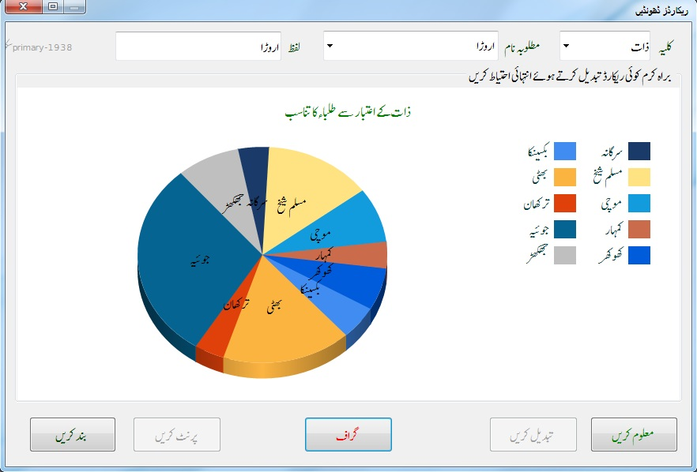

Fig. 4

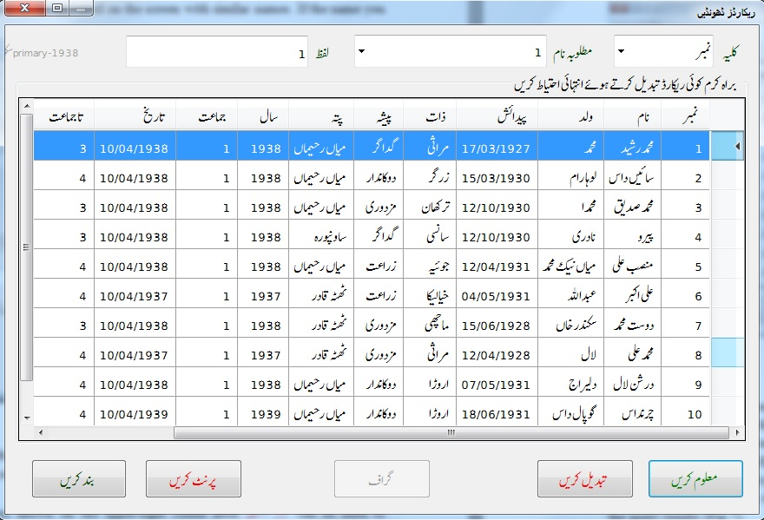

Fig. 5

1. It also shows different types of statistical graphical distribution of the school student. This is shown in Fig. 4 on the next page.
2. It includes strength distribution across different sessions, %age Fail/Pass distribution, students belonging to different villages.
3. A complete printing facility is provided on the type of query you applied. It gives print of a single student in the form of *admission slip* if you select a single row out of the query results (Fig.7).
4. In March 1917, I spared some time and fed over 4000 records of students from different sections of Govt. High School, Misn Rahiman. These records are part of this program. These include,
   1. Primary data (1938-2011) ~ 2011 records
   2. Middle data (1973-2003) ~ 1685 records
   3. High data(1988-1999) ~ 444 records

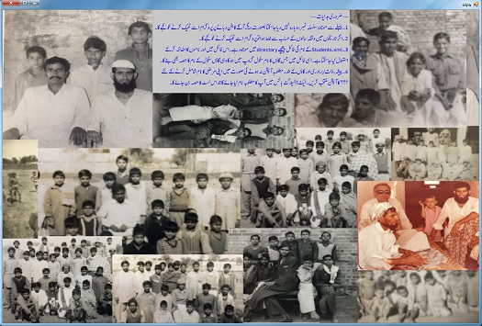

Fig. 6

1. This software development effort is dedicated to all those teachers and staff of this school, whose sincere efforts made this school a working example in such a far flung area like Mian Rahiman. Of course those include,

* Mian M. Walayat Ali Rahimee (1945-2005)
* Mian Muhammad Hussain (1930-2011)
* Mian Fateh Darya (1921-1983)
* Mian Safdar Ali (1937-1997)

and are true deserving of my gratitude.

1. I hope the school administration will depute one person to complete the rest of the record in this software before 2018 which is the 100th anniversary year of this school.

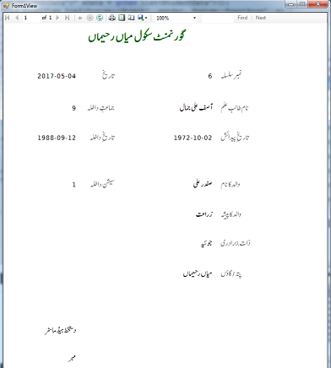

Fig. 7

In this effort following colleagues supported me in solving different issues during the development of this software,

* 1. Mr Amir K. Jadoon
  2. Mr Usman S. Qureshi
  3. Mr Ali Adil
  4. Mr Khalid Mehmood

G. R. Akhtar,

Islamabad.

April 5, 2017.